FHIR Data Obfuscation for Population-Level Analytics

DS522: Data Acquisition and Analytics - USADL - Spring 2025-2026, PyForce
School of Technology and Computing
City University of Seattle
Seattle, WA 98121

Makenzy Abass Gumah,
gumahmakenzyabass@cityuniversity.edu
Jacqueline Biira
biirajacqueline@cityuniversity.edu
Dawit Hailu, MSAI
hailudawith@cityuniversity.edu

Abstract

The growing use of Fast Healthcare Interoperability Resource (FHIR) has opened more opportunities for data-driven innovation in healthcare. However, the presence of personally identifiable information presents significant challenges for secure secondary use. This paper explores FHIR data obfuscation methods that facilitate privacy-protecting analytics, focusing on Project Cumulus, a service by SMART Health IT. Project Cumulus acts as an intermediary between client applications and a FHIR server, systematically removing PII from clinical records while maintaining the semantic details needed for population-level analysis. The paper discusses key design principles such as de-identification workflows, metadata retention, and interoperability safeguards, and assesses how these systems support regulatory compliance, scalable analytics, and trustworthy data exchange. By showing how obfuscation pipelines can balance privacy with utility, this work underscores the importance of privacy-enhancing technologies for secure, standards-based health data ecosystems.

Keywords: FHIR, health data obfuscation, de-identification, SMART Health IT, privacy-preserving analytics, interoperability

1. INTRODUCTION

The rapid expansion of digital infrastructure has driven increased demand for interoperable, analytics-ready client data. Standards such as Fast Healthcare Interoperability Resources (FHIR) have become essential in modern health data exchange, offering structured, API-accessible clinical data across electronic health records (EHRs), health information exchanges, and third-party applications. As adoption of FHIR grows, so does the availability of detailed, high-granularity patient data, useful for research, population health, and quality improvement. However, this expanded access raises patient privacy concerns, especially when data is reused for secondary purposes. Traditional de-identification techniques, designed for static, tabular data, fall short with the complex, nested, and relational structure of FHIR resources. Privacy-enhancing technologies (PETs), particularly FHIR-native obfuscation pipelines, are crucial for enabling secure analytics without compromising the clinical meaning of data. This paper examines such approaches through Project Cumulus, developed by SMART Health IT, which acts as an intermediary between client applications and FHIR servers. By systematically removing personally identifiable information while maintaining clinical relevance, Cumulus showcases how privacy protection can be integrated into standards-based ecosystems. This study contributes to the expanding field of privacy-preserving interoperability by analyzing the design principles, workflows, and impact of FHIR-based obfuscation.

2. LITERATURE REVIEW

Mandel et al. (2016) emphasize how FHIR’s architecture facilitates detailed, machine-readable data exchange, making it suitable for analytics and uniquely supporting application-level interoperability. Early standards focused on message exchanges and static documents, which limited semantic consistency and hindered secondary use. The introduction of FHIR represented a paradigm shift by adopting RESTful APIs, modular resources, and extensible profiles.Research by Lin et al. (2021) showed that identifiers can appear in unexpected fields, including extensions, narrative texts, and device metadata. The study also identified three limitations of FHIR de-identification tools: incomplete identifier detection due to inconsistent field naming across profiles, lack of real-time processing restricting use in live analytics pipelines, and loss of semantic integrity when relationships between resources are broken.Additional studies by Mandl et al. (2020) and Shapiro et al. (2016) highlight that SMART applications frequently access granular patient data, creating a need for privacy layers that operate before data reaches these applications.McMurry et al. (2013) introduced Cumulus, a reverse-proxy service designed to remove PII while maintaining semantic structure. Its architecture aligns with broader industry recommendations and bridges the critical gap identified by previous research—the need for a scalable, real-time obfuscation pipeline compatible with standards and seamlessly integrated into SMART workflows.

3. METHODOLOGY

3.1. DATA ACQUISITION
To facilitate this study without compromising patient privacy or violating Protected Health Information (PHI) regulations, we utilized computationally generated clinical records. Specifically, we leveraged Synthea, a widely adopted, open-source synthetic patient generator that accurately models the longitudinal medical histories of individuals. For the purposes of this research, we acquired a targeted dataset comprising 10,000 simulated patients diagnosed with COVID-19. By utilizing this synthetic cohort, we ensured access to realistic, highly detailed healthcare data—including patient demographics, clinical encounters, diagnostic codes, and medication histories—which provided a robust and secure foundation for our system validation and analysis.

3.2. SERVER DEPLOYMENT
To establish a robust and scalable data infrastructure, a dedicated Fast Healthcare Interoperability Resources (FHIR) server was deployed. While fully featured FHIR specifications inherently support an expansive suite of data models and auxiliary services, the scope of this project required only a specific subset of these capabilities. To avoid the overhead of developing a bespoke solution or over-engineering the architecture, we utilized HAPI-FHIR, a prominent, open-source Java implementation of the FHIR specification. This selection provided a compliant, highly extensible foundation without necessitating the ground-up configuration of redundant services.
The production environment was provisioned using Amazon Web Services (AWS) to ensure high availability, security, and elasticity. The HAPI-FHIR application was deployed on an Amazon Elastic Compute Cloud (EC2) instance, which served as the primary application server. Following the initial provisioning, the environment underwent systematic validation to confirm container or server stability and API responsiveness.
Because the HAPI-FHIR framework relies on a relational database management system for persistent storage, Amazon Aurora PostgreSQL-Compatible Edition (RDS) was selected as the database backend. This choice offered superior performance, automated scaling, and fault tolerance compared to a standard PostgreSQL deployment. Reliable, low-latency connectivity was established between the EC2 application layer and the Aurora RDS database cluster, utilizing securely configured AWS Virtual Private Cloud (VPC) security groups to restrict data access and ensure compliance with standard healthcare data-protection practices.

3.3. DATA CLEANING AND LOADING
The raw synthetic patient records generated by Synthea are natively output in standard comma-separated values (CSV) format. However, to ensure interoperability with our established AWS infrastructure, the data needed to conform to the Health Level Seven (HL7) Fast Healthcare Interoperability Resources (FHIR) Release 4 (R4) specification. To bridge this structural disparity between flat tabular files and hierarchical FHIR schemas, we implemented a dedicated data loader module. This module operates as an Extract, Transform, Load (ETL) pipeline: it parses the raw CSV files, maps the disparate clinical data points to their corresponding FHIR R4 resource models (such as Patient, Condition, Observation, and Encounter), and converts the records into valid FHIR JSON bundles. Once transformed, these standardized bundles are securely transmitted and ingested into the HAPI-FHIR server.

3.4. DATA INGESTION AND EVALUATION
To quantitatively validate the success of the ETL process and ensure the integrity of the server population, a primary RESTful query was executed against the HAPI-FHIR endpoint (GET /Patient?_summary=count). The server successfully responded with a total population of 12,152 patients. This confirmed that the complete synthetic cohort was securely hosted and that the API was fully responsive to summary-level demographic queries.

3.5. DATA STORAGE AND INTEGRATION
Following broad validation, a detailed exploratory data analysis (EDA) was conducted to verify the clinical depth of the ingested records. A representative sub-cohort of 1,000 patients was systematically sampled from the database. For each patient within this sample, an automated analytical pipeline extracted core demographic attributes—specifically utilizing the birthDate field to stratify individuals into discrete age cohorts (0-18, 18-39, 40-64, and Unknown). Concurrently, the pipeline queried individual patient clinical histories against predefined COVID-19 diagnostic codes to compute an active symptom count, alongside verifying their definitive COVID-19 diagnostic status (Positive vs. Negative)

4. RESULTS

4.1. PRELIMINARY DATA ANALYSIS
The overarching objective of this research is to evaluate the efficacy of utilizing obfuscated, synthetic healthcare datasets to conduct robust population-level analyses without compromising patient privacy. To this end, our initial exploratory data analysis serves as a critical proof-of-concept. By querying the HAPI-FHIR server, we sought to determine if computationally generated, anonymized cohorts could yield discernible and clinically plausible macro-level trends.

The initial extraction and stratification of a 1,000-patient sub-cohort successfully demonstrated the analytical viability of the obfuscated dataset. As illustrated in the symptom density distribution analysis (see Figure 6.4), the data allowed us to map the symptom burden across the population, revealing clear clinical stratifications between COVID-19 positive and negative cohorts across all measured age demographics.

5. FUTURE WORK

These preliminary findings confirm that the underlying FHIR infrastructure and the obfuscated dataset are technically sound and analytically viable. Crucially, they demonstrate that privacy-preserving synthetic data can be effectively queried to extract meaningful epidemiological patterns. With this foundational validation complete, the next phases of this project will utilize this infrastructure to execute more complex, large-scale population health initiatives, such as longitudinal outcome tracking, predictive modeling, or resource allocation simulations.

6. FIGURES

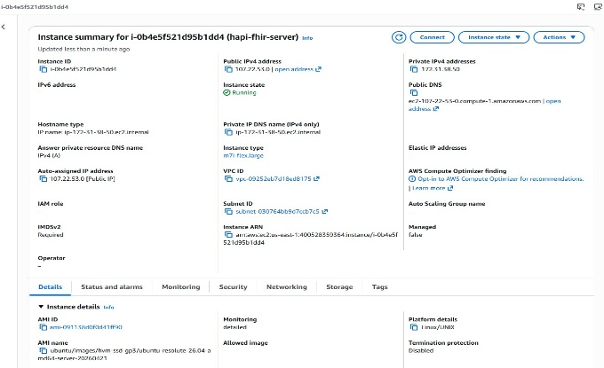
Figure 6.1 AWS Elastic Compute Cloud (EC2) console demonstrating the active deployment state of the primary HAPI-FHIR application server.

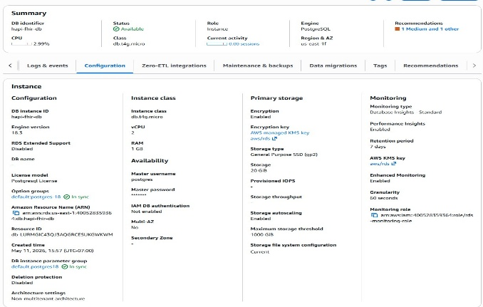
Figure 6.2 AWS Aurora RDS Management Console displaying the active PostgreSQL-compatible database cluster.

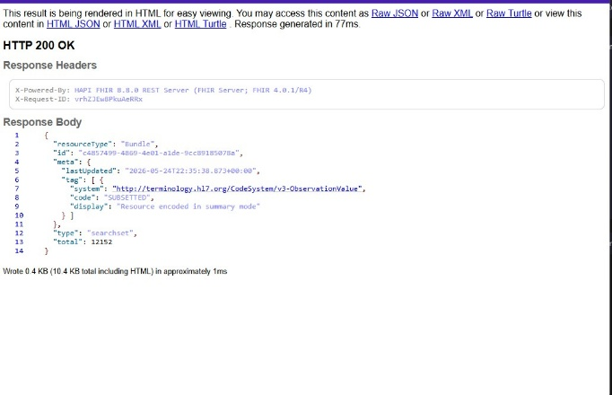
Figure 6.3 Successful RESTful API response generated via the HAPI-FHIR GET /Patient endpoint.

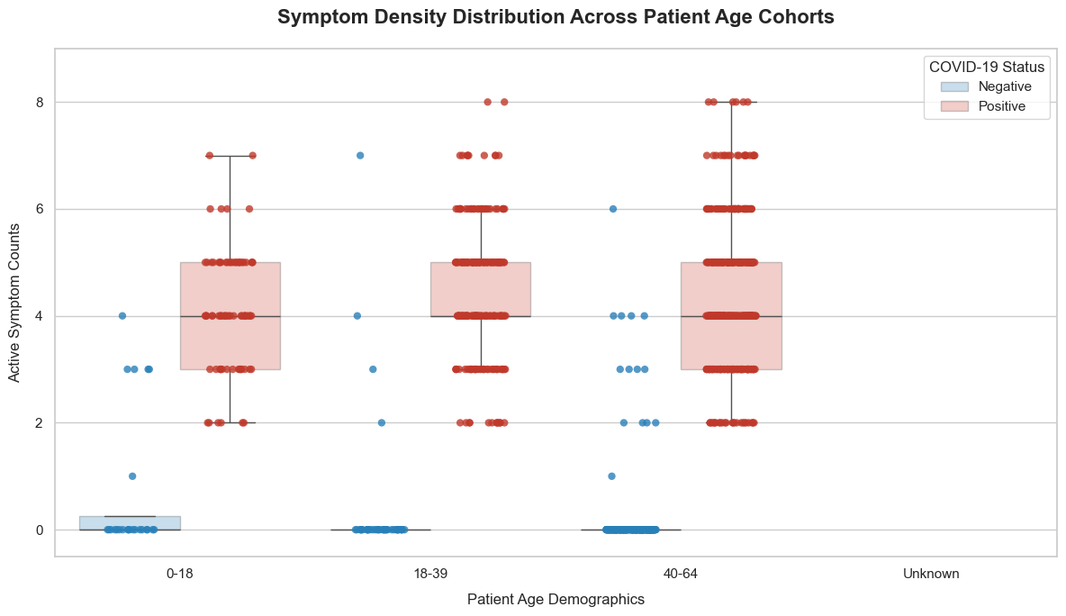
Figure 6.4 A box and strip plot illustrating the distribution of active COVID-19 symptom counts stratified by patient age demographics (0-18, 18-39, 40-64, and Unknown) and diagnostic status.

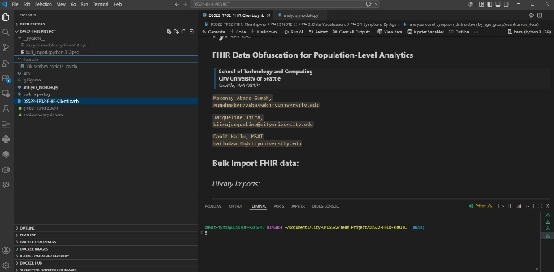
Figure 6.5 The Jupyter Notebook development environment.

7. REFERENCES

Bender, D., & Sartipi, K. (2013). HL7 FHIR: An agile and RESTful approach to healthcare information exchange. Proceedings of the 26th IEEE International Symposium on Computer-Based Medical Systems, 326-331
Mandl, K.D., Gottlieb, D., Ellis, A., & Kohane, I. S. (2020) The SMART Platform: Early experience enabling substitutable applications for electronic health records. Journal of the American Medical Informatics Association, 27(2), 224-232.
McMurry, J.A., Murphy, S.N., MacFadden, D., Weber, G., Simons, W. W., Orechia, J., & Kohane, I. S. (2013). Cumulus: A cloud-based system for de-identified aggregate analytics on health data. AMIA Annual Symposium Proceedings, 2013, 1000-1009.
Dawit-Hailu. (n.d.). GitHub - dawit-hailu/DS522-FHIR-PROJECT. GitHub. https://github.com/dawit-hailu/DS522-FHIR-PROJECT

